Thyroid detection

|  |  |
| --- | --- |
| Written By | Rohan Negi |
| Document Version | Architecture |
| Last Revised Date | 10-3-2022 |

**Document Control**

**Change Record:**

|  |  |  |  |
| --- | --- | --- | --- |
| **Version** | **Date** | **Author** | **Comments** |
| **0.1** | **10-3-2022** | **Rohan** | **Architecture data creation.** |
| **0.2** | **10-03-2022** | **Rohan** | **Document updated.** |
|  |  |  |  |
|  |  |  |  |
|  |  |  |  |

# Contents

1. Architecture...................................................................................................................

2 Architecture Description...............................................................................................

1. Architecture

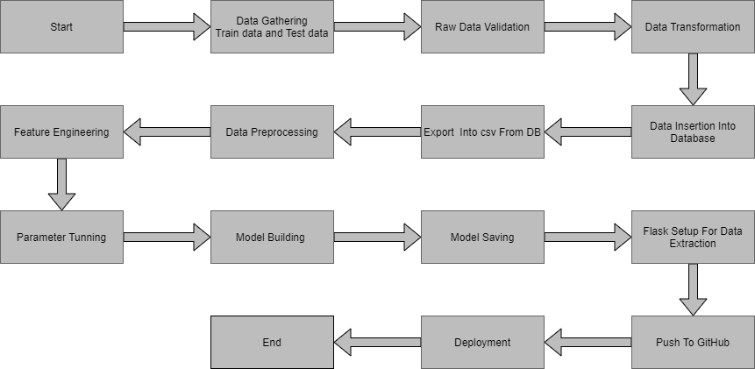2. Architecture Description

2.1. Data Description

The data required for the building of the project is already available on the dashboard. The client will send data in multiple sets of files in batches at a given location.

Data will contain Thyroid level and 31 columns of different values of the report.

|  |  |  |
| --- | --- | --- |
| Name | Data Type | Measurement |
| Age | Float | Age of the person |
| Sex | Boolean | Sex of the person |
| on_thyroxine | Boolean | Person is on thyroxine or not |
| on_antithyroid_medication | Boolean | Person is on anti thyroid medication or not |
| L131 treatment | Boolean | The person had done l131 treatment or not |
| Query hypothyroid | Boolean | Has query on hypothroid or not |
| Goitre | Boolean | Goitre present or not |
| Psych | Boolean | Has psychological disfunction or not |
| Tsh measured | Boolean | Is tsh measured or not |
| Tsh | float | Value or tsh |
| T3 measured | Boolean | Is t3 measured or not |
| T3 | Float | Value or t3 |

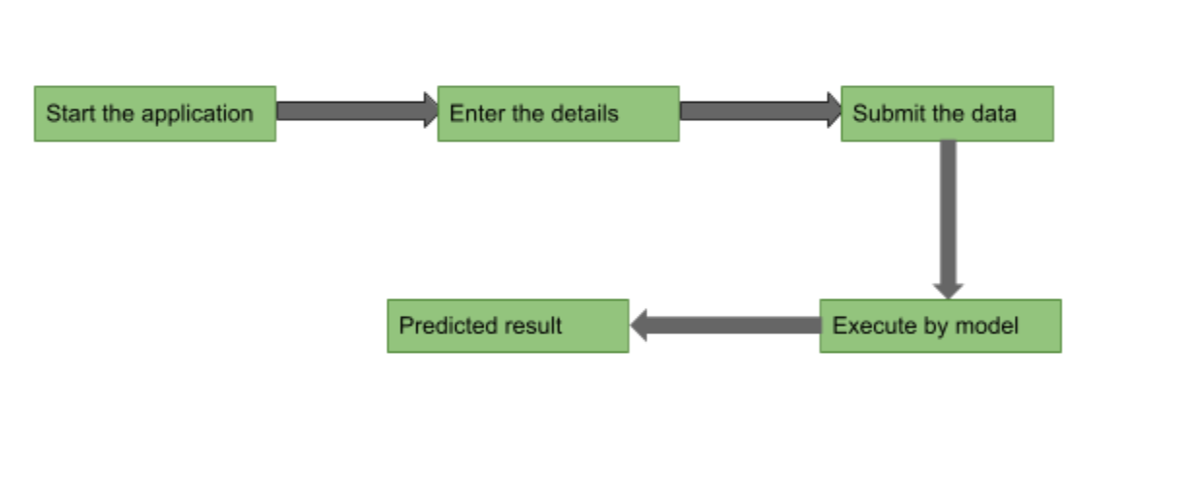

3. Unit Test Cases

|  |  |  |
| --- | --- | --- |
| Test Case Description | Pre-Requisite | Expected Result |
| Verify whether the Application URL is  accessible to the user | 1. Application URL  should be defined | Application URL should be  accessible to the user |
| Verify whether the Application loads  completely for the user when the URL  is accessed | 1. Application URL  is accessible  2. Application is  deployed | The Application should load  completely for the user when the  URL is accessed |
| Verify whether user is able to see input  fields | 1. Application is  accessible | User should be able to see input  fields |
| Verify whether user gets Submit  button to submit the inputs | 1. Application is  accessible | User should get Submit button to  submit the inputs |
| Verify whether the predicted  results are in accordance to the  selections user made | 1. Application is  accessible | The predicted results should  be in accordance to the selections  user made |